Assignment – Simple Storage Service (S3)
1. S3-Bucket-Creation-Assignment-–-1
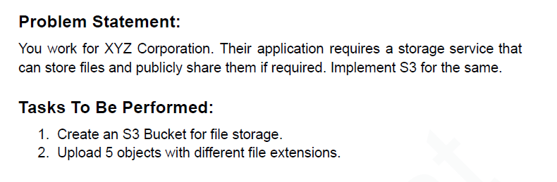
1. Create an S3 Bucket for file storage.
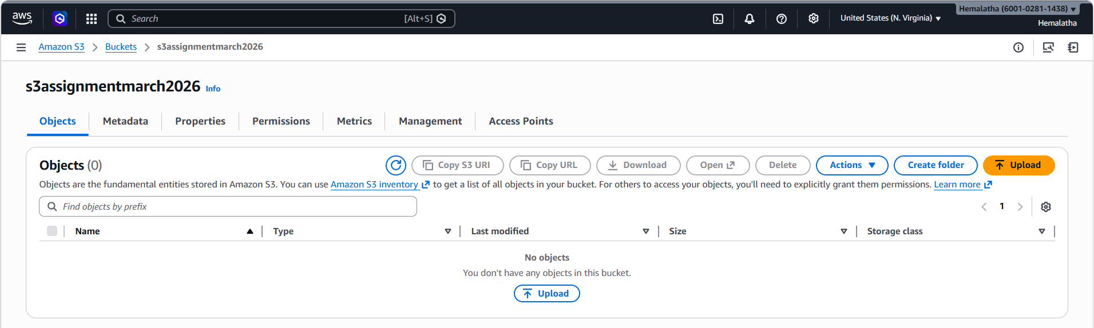
2. Upload 5 objects with different file extensions.
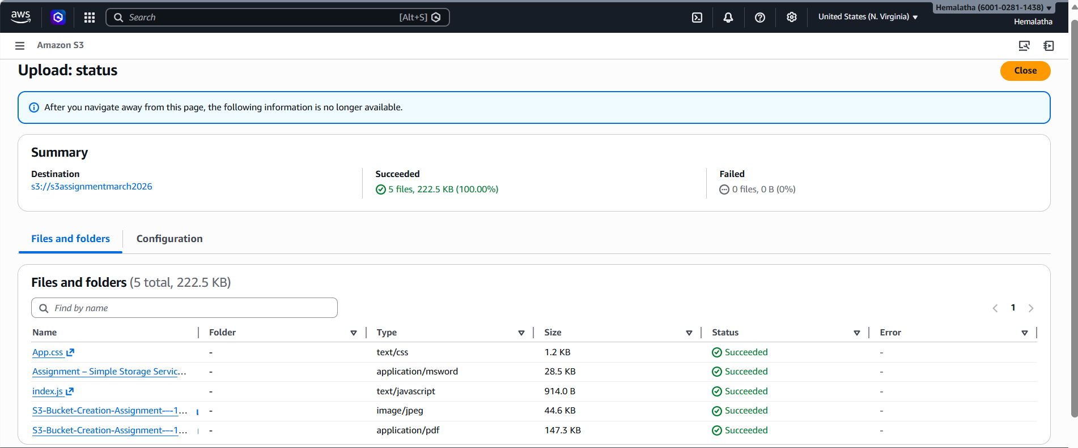
2. S3-Bucket-Versioning-Assignment-–-2
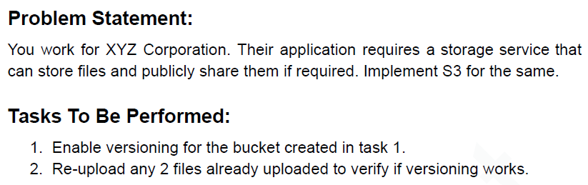
1. Enable versioning for the bucket created in task 1.
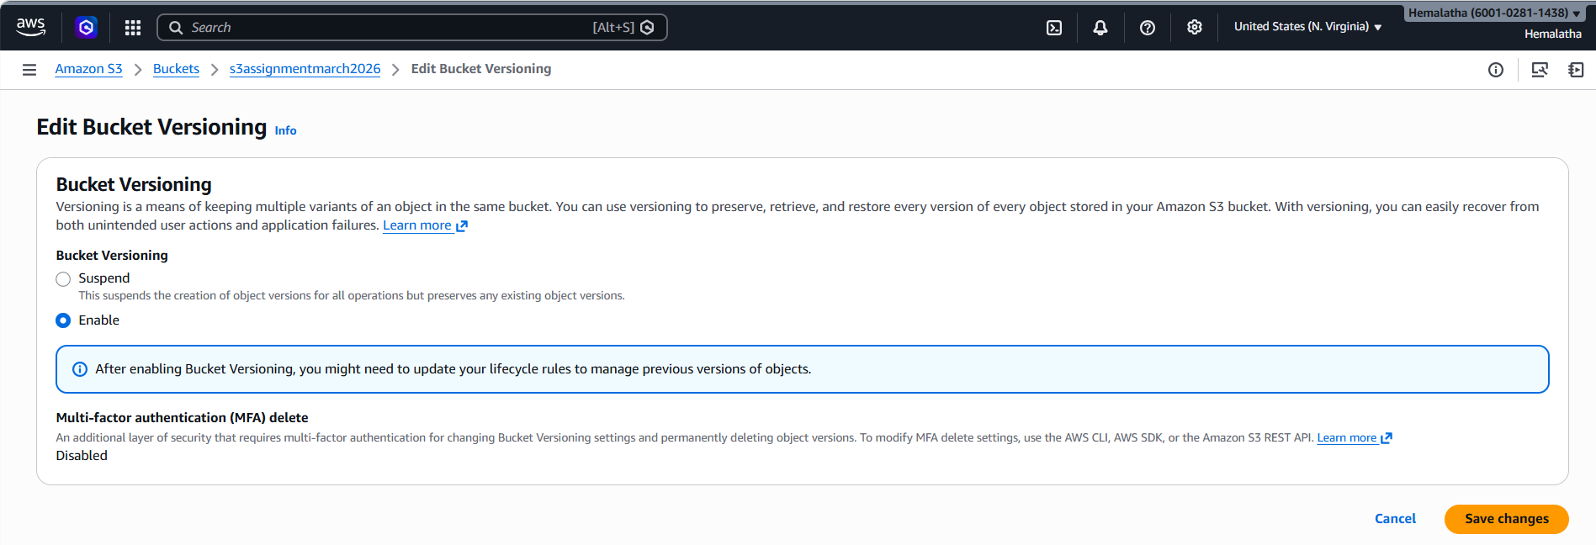
2. Re-upload any 2 files already uploaded to verify if versioning works.
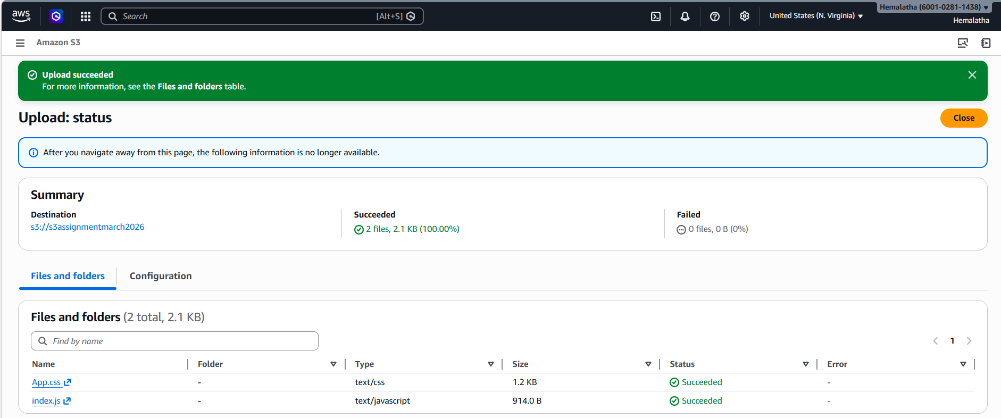
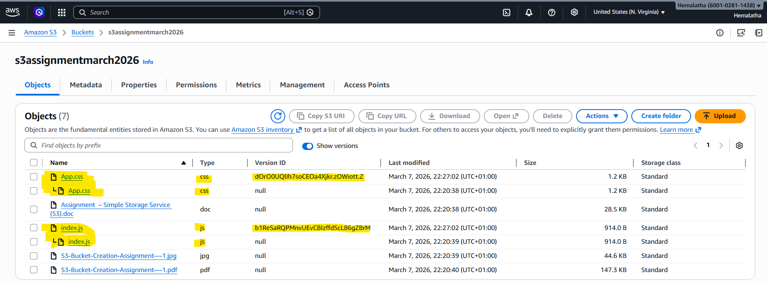

3. S3-Website-Hosting-Assignment-–-3
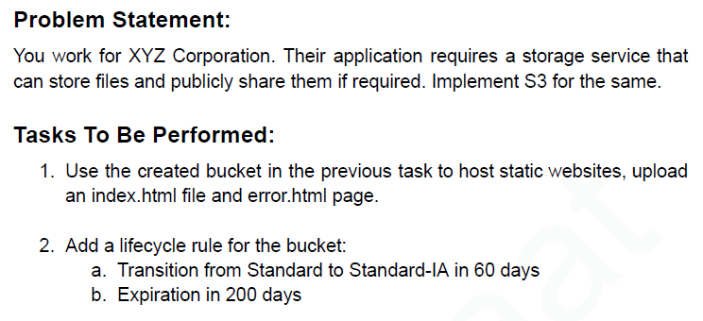
1. Use the created bucket in the previous task to host static websites, upload an index.html file and error.html page.
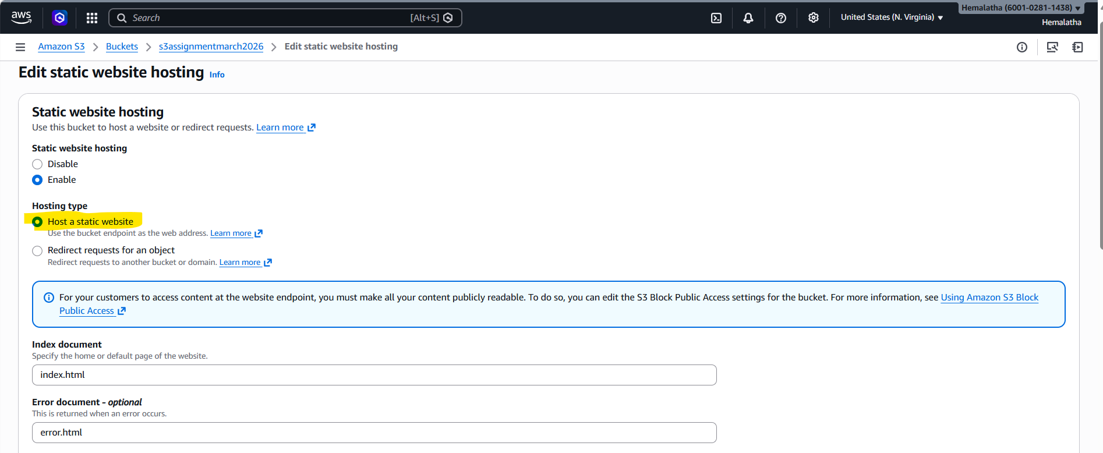
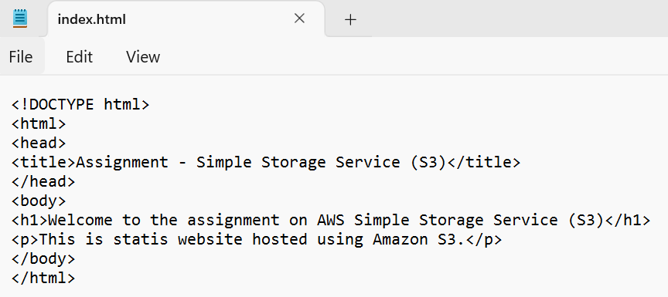

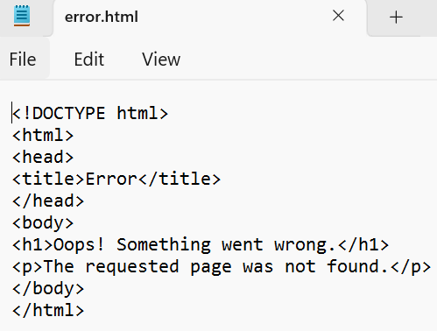

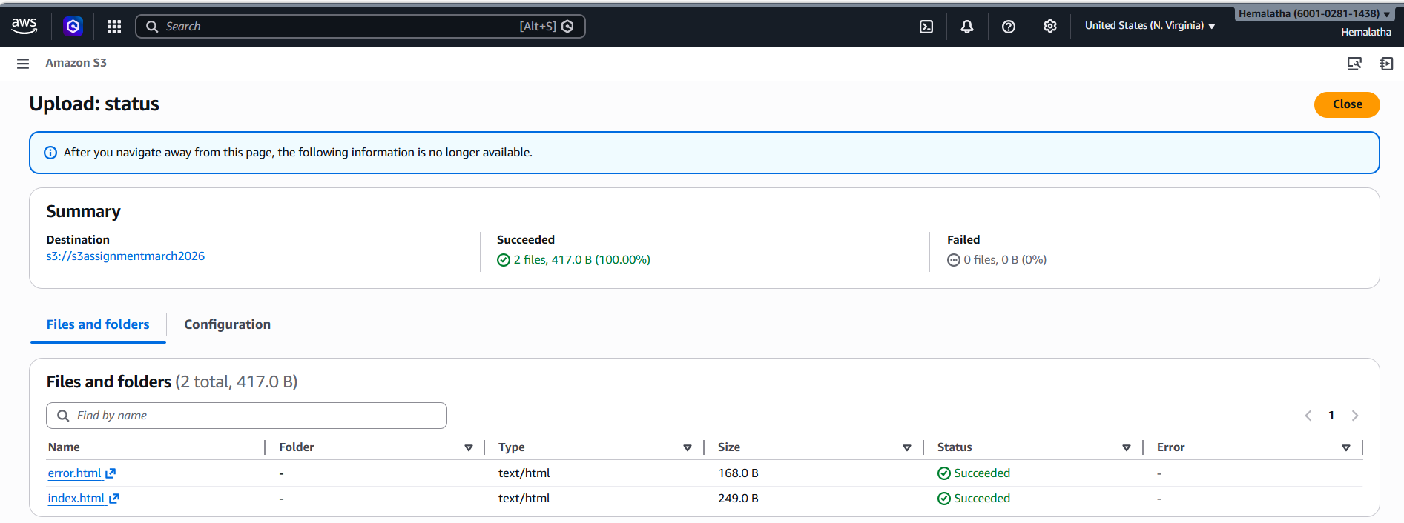

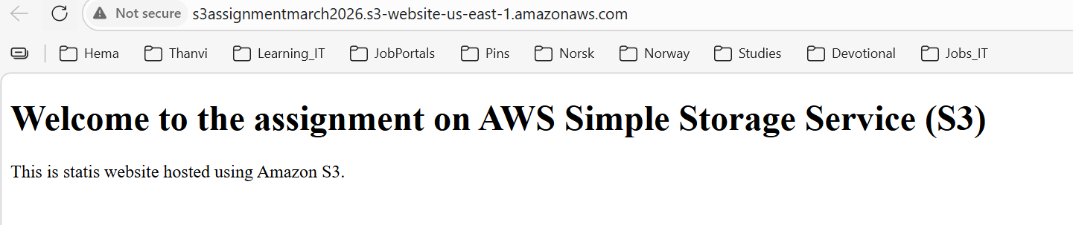

2. Add a lifecycle rule for the bucket:
a. Transition from Standard to Standard-IA in 60 days
b. Expiration in 200 days

